Semiconductor quantum light sources
Michael E. Reimer
Kavli Institute of Nanoscience, Delft University of Technology, Delft, The Netherlands
Ways to generate coherent and efficient, regulated streams of single photons or entangled photon pairs are needed in development of future quantum technologies such as communication between remote nodes in a quantum network and implementation of integrated quantum photonic circuits. For practical implementation, a Gaussian emission profile is essential so that the light couples efficiently to a single-mode optical fiber or to on-chip waveguides.
In this talk, I first discuss how we have realized an ‘ideal’ single-photon emitter in the solid-state using nanowire heterostructures by precisely controlling the quantum dot position, nanowire shape, and construction. I will show how we position the quantum dot on the nanowire waveguide axis and shape the nanowire tip during growth in order to achieve a very bright single-photon source [1, 2]. For practical implementation, we demonstrate a near-perfect coupling of the quantum dot emission to a single-mode optical fiber owing to the Gaussian emission profile provided by the nanowire (see Figure 1).
Next, I will show how we have achieved the narrowest quantum dot emission linewidth to date by carefully controlling the crystal phase quality of the nanowire during growth to be of the pure wurtzite structure. In contrast to conventional self-assembled quantum dots, this narrowest linewidth is not attained at very low excitation powers, but at the excitation power where the quantum dot emission is brightest.
Finally, I will present an optical approach to generate time-bin entangled photon pairs on demand. We convert polarization entangled photons from a single quantum dot into time-bin entangled photons by sending them through an interferometer. Additionally, by sending the time-bin entangled photons back through the same interferometer we recover polarization entangled photons. Time-bin entanglement is more suitable for long-distance quantum communication than polarization entanglement, since time-bin entangled photons are insensitive to birefringence in optical fibers.
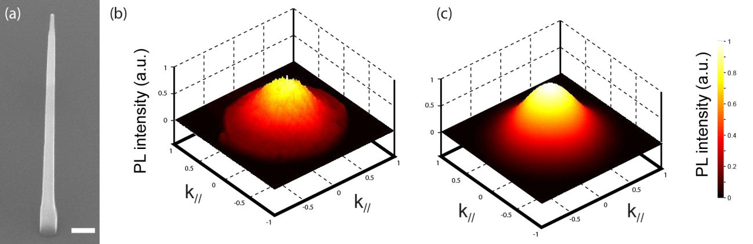
Figure 1: (a) SEM image of tapered nanowire waveguide containing an embedded quantum dot perfectly positioned on its axis. Scale bar, 200 nm. (b) Measured and (c) calculated far field emission profile of a single quantum dot in tapered nanowire waveguide. The emission pattern is a Gaussian and has an excellent overlap (99%) with the mode profile of a single-mode fiber.

References

[1] M.E. Reimer et al., Nature Commun. 3, 737 (2012).
[2] G. Bulgarini et al., Appl. Phys. Lett. 100, 121106 (2012).
[3] D. Dalacu et al., Nano Lett. 12 (11), 5919-5923 (2012).

