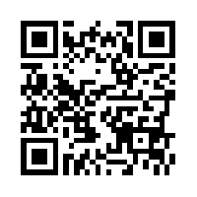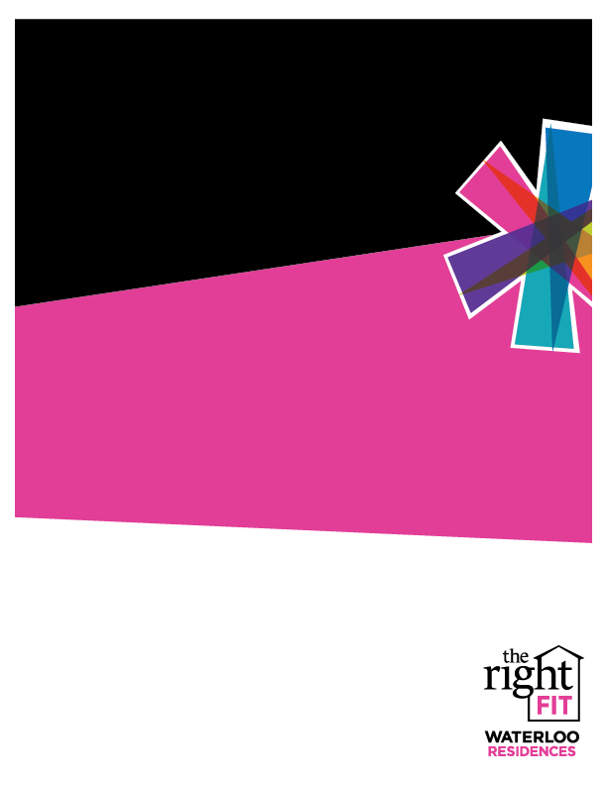

Friday, March 24th, 7 pm to Sunday, March 26th, 5 pm

25th Annual University of Waterloo Juggling Festival– 200 University Ave., Waterloo – University of Waterloo

You and your neighbours are invited to join the fun at the annual Juggling Festival! Special juggling events will be taking place all weekend. Try your hands out at Juggling Workshops, games, and much more! For more information and the complete event and workshop schedule, please visit: [Facebook](https://www.facebook.com/events/1803774829862123/).

March events are LIVE! Register [HERE](https://www.eventbrite.ca/o/columbia-lake-village-graduate-community-2842430704).

Saturday, March 25th, 6 pm – 10 pm

Earth Hour Festival- SCI– 200 University Ave., Waterloo – Village 1 Great Hall

Join University of Waterloo’s Sustainable Campus Initiative (SCI) as they celebrate Earth Hour. Together you will pledge to reduce energy use for one hour from 8:30 to 9:30 PM. Prizes, free food, and games will also be provided throughout the hour. For more information, please visit: [FEDS](http://www.feds.ca/event/earth-hour-festival-2017/).

Friday, March 24th, 1 pm – 4 pm

Winter Wrap Up Week – Ted Talks and Chill – 200 University Ave., Waterloo – Student Life Centre

Check out the fantastic line-up of Ted Talks playing on the big screen in the SLC. Topics include stress-free productivity, programming your mind for success, building the skill of self confidence, and much more! FREE popcorn will also be provided! For more information, please visit: [Facebook](https://www.facebook.com/events/1399892130073401/).

March 24th - March 26th

Weekend Idea

CLV Single Grads